ALLERGY MATRIX
DISHES | 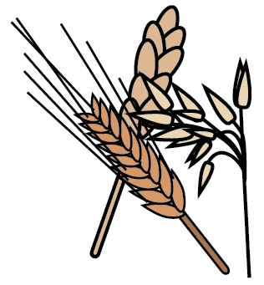 |  | 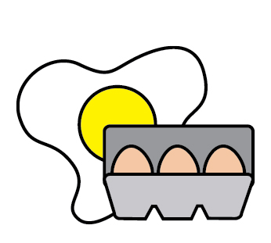 |  |  | 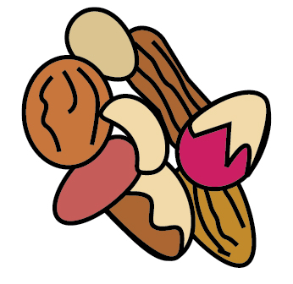 | 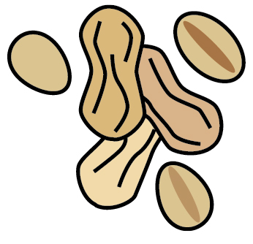 | 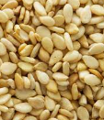
 | Wheat | Milk | Egg | Soy | Fish | Tree Nuts | Peanuts | Sesame
Pepperoni Pizza | √ | √ |  | √
Cheese Pizza | √ | √ |  | √
Beef Patty |  |  |  | √
Chicken Patty | √ | √
Veggie Pattie | √ |  |  | √
Burger Buns | √ |  |  | √ |  |  |  | √
Blueberry Muffin | √ | √ | √
Chocolate Chip Muffin | √ | √ | √ | √ |  | √ | √
Otis Spunkmeyer Cookie | √ | √ | √ | √ |  | √ | √

Last Reviewed July 2023

